Chapter 19, Problem 85.

At ω = 1 rad/s, find the transmission parameters of the network in Fig.19.127 using PSpice.

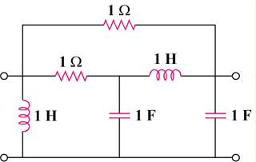

Figure 19.127
For Prob. 19.85.

